Lab 2 – JavaScript Documentation

Progress Overview
I started out by creating a contact.html document, then made sure the contact form was dynamically loaded into the main page using fetch(), making it appear directly in the Contact section. I then moved on to my contact.js file, where I implemented validation for all required contact form fields. First and last name fields now only accept letters, the email field checks for a basic valid format, and the message field requires at least 20 characters. A real-time character counter shows progress for the message field, turning red when below 20 characters and green when the requirement is met.

Challenges and Solutions

CORS issues
The form didn’t appear when opening the page locally due to CORS issues. Using VS Code Live Server solved this. Selecting form fields initially returned null because the script ran before the form was in the DOM. Calling initContactForm() after the fetch fixed this issue.
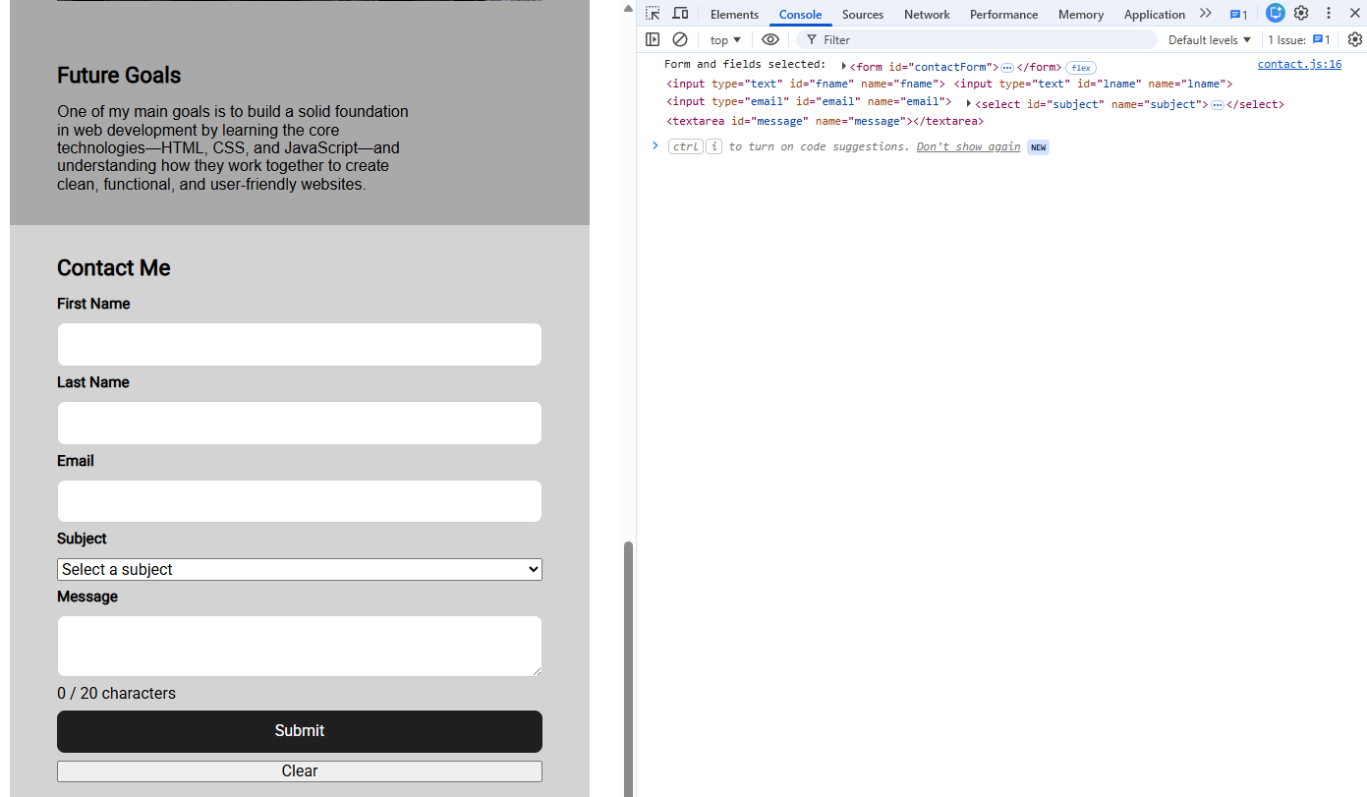

Figure 1. Screenshot showing the form and the console after fix.

Conflicting feedback with counter and blur validation

A challenge was coordinating the real-time character counter with the message field validation. The counter and the blur validation could give conflicting feedback to the user if it wasn’t handled correctly. I solved this by separating the logic: the counter updates on every input, while the validation checks the length on blur, ensuring consistent and accurate feedback.
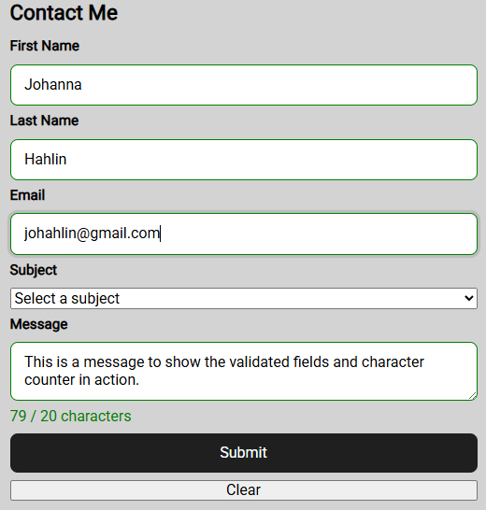

Figure 2 Screenshot showing the validated fields and character counter in action.

Git Workflow
My second commit (after the initial one) was made when I felt like I had made reasonable progress, with the message: “Fetch contact form and initialize DOM elements”, showing integration of the form and setup of JS selectors.
I made my third commit after implementing all field validations, with the message:
“Add form field validation for names, email, and message with character counter.”
This clearly documents the milestone before moving on to form submission handling.

